Workshop: Current and future applications of non-invasive and invasive BCIs
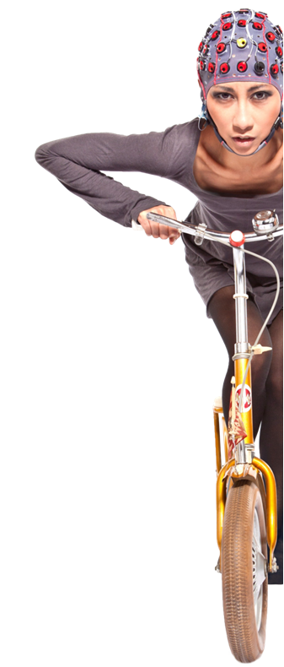
“Gheorghe Asachi’’ Technical University of Iasi & Rehabilitation Hospital of Iasi &g.tec medical engineering Austria

May 19th, 2017
Venue: Faculty of Electrical Engineering, Technical University of Iasi
Room: “Dragomir Hurmuzescu” Conference Hall
Address: 21-22 D. Mangeron str., Iasi
Tel:+40232-278683
Fax: +40232-237627
http://www.ee.tuiasi.ro

About the Workshop
Research groups all over the world have been working enthusiastically on Brain-

Computer Interfaces (BCIs), which provide a direct connection from the human brain
Toa computer. BCIs translate brain activity into control signals for numerous applications,
including tools to help severely disabled users communicate and improve their quality of life. BCIs
have been used to restore movement, assess cognitive functioning, and provide communication and environmental control. During this workshop, we will demonstrate the three major BCI approaches
motor imagery, P300 and steady state visual evoked potentials (SSVEP) - for spelling, assessment, rehabilitation and robot control. We will also explain new directions like active and dry electrodes, invasive ECoG systems and advanced VR control. The audience will see all the required hardware and software, procedures for cap mounting, training and classifier setup, and BCI operation. We will invite audience members to participate in live demonstrations, providing real-world examples of modern BCI performance in field settings.
Program:

9:00 Workshop Opening
9:30 Marian-Silviu Poboroniuc:TUIASI research related to BCI-based Rehabilitation

10:00 Bogdan Ignat: Increasing chances for recovery in stroke - from theoretical potential to real life applications

10:30 Coffee break

10:40 Francisco Fernandes & Danut Irimia: Introduction to major methodological approaches of BCI & introduction to hard- and software. Theoretical preparation of the hands-on experiments.
12:00 Lunch break
13:00 Hands-on sessions:BCI live
experiments, g.Nautilus,RecoveriX

16:00 Final discussion & questions

Attendance is free of charge but registration is required due to limitation of space. Please contact: Marian Poboroniuc mpobor@tuiasi.ro, Francisco Fernandes: fernandes@gtec.at
N.B.:The workshop will be held in English.
Speakers:

Marian-Silviu Poboroniuc is Habilitated Professor for Robotics &Neuroprostheses at TUIASI. His current research interests involve mobile robots control algorithms, human motion analysis and synthesis, neuroprosthetics, biomechanics, brain-computer interfaces and rehabilitation robotics (e.g. NOVAFES 267/2014-Innovative garments with embedded electrodes for functional electrical stimulation based rehabilitation, IHRG 150/2012 – An intelligent haptic robot glove for the patients suffering a CVA). He is actively involved in several national and international research projects, of which most are related to neuroprostheses design and control, BCI and to increasing the pool of qualified Electrical and Information Engineering graduates across Europe (e.g. SALEIE EU project).

Bogdan Ignat is a lecturer at the Neurology Chair of the "Gr. T Popa" Medical University in Iasi and a senior neurologist at the Clinical Rehabilitation Hospital in Iasi. He is involved in various research projects regarding stroke rehabilitation (e.g. IHRG 150/2012, NOVAFES 267/2014, EXOSLIM 180/2012), mostly in partnership with the ALGCON laboratory at Faculty of Electrical Engineering, TUIASI.

Francisco Fernandesis the Regional Sales Officer of g.tec medical engineering GmbH responsible for the Romanian market, between others. Specialised in the commercialization of medical devices, he has been working with g.tec since 2014.

Danut-Constantin Irimia is an Assistant Professor for Robotics and System Theory at TUIASI. Since 2012 he is also a research collaborator of g.tec medical engineering GmbH focusing on biomedical signal processing and Brain-Computer Interfaces for post-stroke rehabilitation.

Workshop: Current and future applications of non-invasive and invasive BCIs

“Gheorghe Asachi’’ Technical University of Iasi & Rehabilitation Hospital of Iasi &g.tec medical engineering Austria

May 19th, 2017

Venue: Faculty of Electrical Engineering, Technical University of Iasi

Room: “Dragomir Hurmuzescu” Conference Hall
Address: 21-22 D. Mangeron str., Iasi
Tel:+40232-278683
Fax: +40232-237627
http://www.ee.tuiasi.ro

Registration Form:

Please fill in and fax back: 0040232-237627
or email it to:

Marian Poboroniuc mpobor@tuiasi.ro and

Francisco Fernandes: fernandes@gtec.at

Name & Degree (as to appear on workshop materials):
________________________________________________________
Institution/Affiliation:
________________________________________________________
Department:
________________________________________________________
Business Address:
________________________________________________________

City: ___________________ State: ________ Zip: _______________

Business Phone: _________________________________________
E-mail Address (important for receiving the confirmation)
________________________________________________________

